1.0 Introduction

In the 2021 Bill and Melinda Gates Goalkeepers reported a maternal mortality 158.8 deaths per 100,000 live births (), using date from the global health data exchange (). Health data is vital in assessing the factors that contribute to maternal mortality. For this assessment a csv file is provided that contains data on a person’s age, systolic blood pressure, heart rate, blood sugar, diastolic blood pressure and maternal risk level. The risk level consists of three categories low, mid and high.

jupyjhj2.0 Analysis

2.1 Cleaning

Initial exploratory data analysis is performed to detect and correct corrupt or incorrect data. This is simply done by plotting the variables and looking closely for anomalous data. One of these errors is present in the heart rate feature. This anomalous result was removed as a heart rate of 7 is mostly likely a typo.

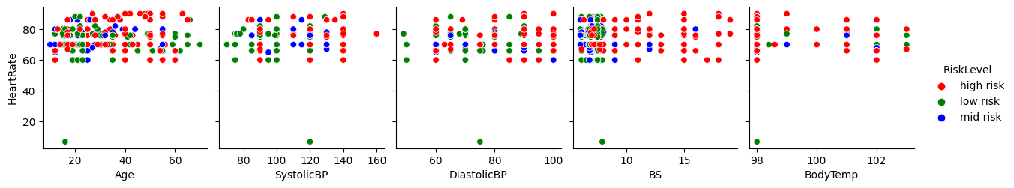
Figure 1 – Heart rate scatter plots reveal someone with a less than 10 heart rate. This error must be dealt with accordingly.

2.2 Linear Regression

Linear regression is useful model to use because of the its simple and fast nature [3]. The model can take any number of dependent variables to predict one independent. Such model can be used to predict systolic blood pressure from the dataset features. This would predict a value without the use of an expensive machine. The total number of linear models can calculated using the total number combinations. As there are 6 numerical features with one target, therefore 31 possible unique models.
Therefore it’s possible to perform an exhaustive feature search. Using forward selection each combination will be fitted and then evaluated on mean squared error. The lowest model is then chosen.

Model Number | Features | Mean absolute error | Mean squared error
1 | DiastolicBP, Age, BS, BodyTemp | 8.89 | 125.25
2 | Age, BS, BodyTemp, HeartRate | 13.07 | 248.18
3 | Age, BS | 13.65 | 261.33
Table 1 – Three linear regression models using different features. Each evaluation metric is the mean of 8 cross validated folds.

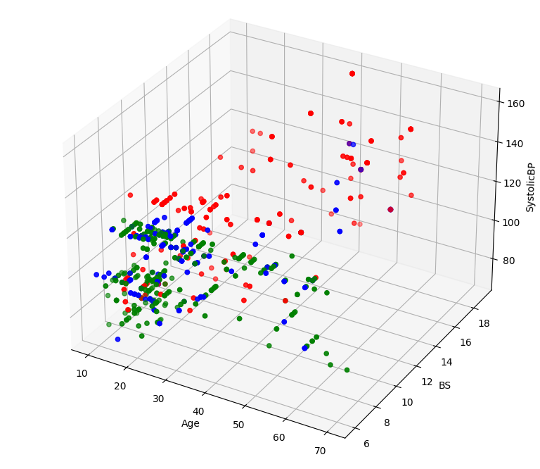
Three notable models are shown in table 1. The first model has the overall best performance, but has limited use cases. Systolic and diastolic blood pressure are closely related as systolic is when the heart beats and diastolic blood pressure is when the hearts rests [maybe]. Therefore both measurements are made at the same time its no wonder they are related. If diastolic BP is removed from the exhaustive search model 2 becomes the best performer. However this model still includes body temp and heart rate despite the correlation of heart rate being no exist in this data. And only a low correlation with bodytemp has a none existent correlation figure 2.
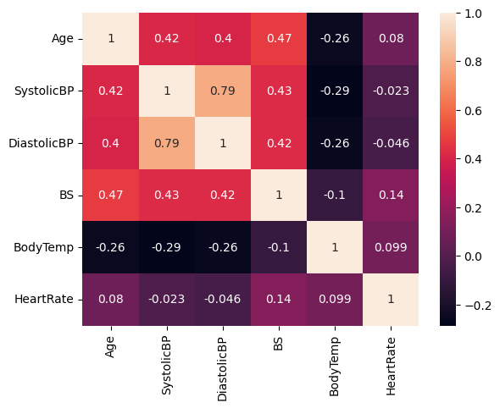

Figure 2 – Correlation matrix.

It is true that heart rate and body temperature can be correlated to blood pressure but often in specific circumstance. Blood pressure is related to heart rate only when the body struggles to regulate itself as when heart rate gets too high [4]. Body temperature can be related in elderly people but is not generally [5]. With this removed model 3 is produced which only has had minimal performance loss. This model as the advantage that it is simpler, but still provides sufficient predictions. It can also be visualized as shown in figure 3.

Figure 3 – Three dimensional plot of age, blood sugar and systolic blood pressure. Where red is high risk, mid risk blue and low risk green.
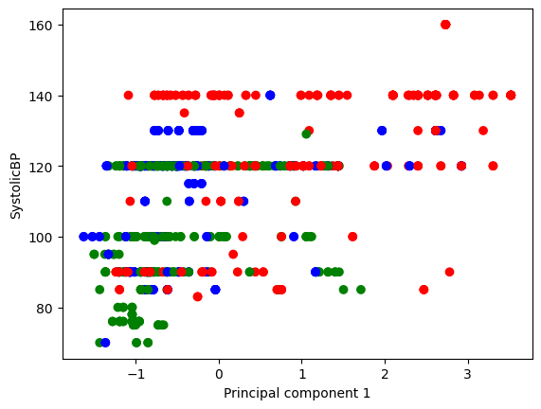

2.3 Principle component analysis

When handling multivariate data principle component analysis (PCA) can be an extremely helpful tool for any data scientist. The goal of a PCA model in to reduce the dimensionality of the data while retaining the most information possible []. This becomes useful in cases with a large number of features. As operations performed on the scaled PCA data has less data point they are much faster.
PCA can be performed on the data given, as an example we can take the three dimensional plot in figure 3 and reduce them to 2. This allows a much clearer visualization as shown in figure 4.

Figure 4 – Age and blood sugar reduced using PCA to component 1 then plotted against systolic blood pressure. Where red is high risk, mid risk blue and low risk green.

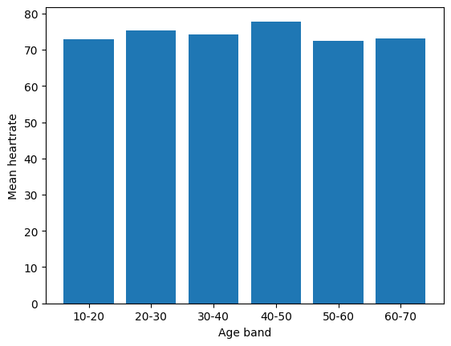
2.4 Age and heart rate

An alternate way to visualize the way age and heart rate are correlated is to bin the data. The ages can be binned into 10 year ranges, then the mean can be calculated within these ranges. Figure 5 shows the produced plot. The plot shows little difference in heart rate between the bands this is expected. Assuming the data is resting heart rate which does not change with age, only the maximum heart rate during exercise does []. Groups of 10 were chosen as it allows enough people in each group. In this case there were 42 people between 60-70 any lower would might cause problems with sample size.

Figure 5 – Bar plot showing the mean heart rate for 10 year groups up.

2.5 Association rules for blood pressure

Association rule learning can be useful statistical technique to understand relationships within a dataset. Two variables a and b can be tested for interesting relationship by calculating a number rules. The first rule is support which calculates how frequent a set appears in the data set. For example the percent of total transactions contain bread and butter. Secondly, confidence tells the probability of a occurring given that b is in the set. So determines how often the rule is actually correct. Using the two previous rules conviction can be calculated. Which asks when a occurs without b, hence how frequent an incorrect prediction happens. The final association is lift which gives information on whether the association is dependent or independent. [9]

Three relationships are tested in table 1 between systolic blood pressure and diastolic blood pressure. The first is where in both cases are the high range defined as systolic over 140 and diastolic over 90. From the low support tells us this only happens in 0.9% of cases. As the confidence is 1 the both blood pressure are always high together, this is also why conviction is infinite. The lift is greater than 1 so the associations are dependent on each other. The next two rules are similar to each other. Both are a strong minority of the dataset and are dependent on each other, with low more so.

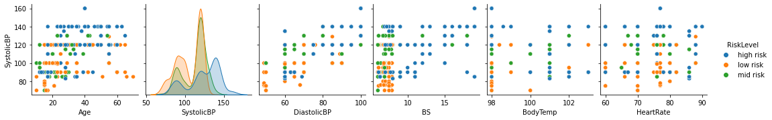
Relationship | Support | Confidence | Conviction | Lift
High and High | 0.009862 | 1.00 | inf | 8.240
Mid and Mid | 0.278 | 0.540 | 1.50 | 1756
Low and Low | 0.266 | 0.780 | 3.180 | 2514
Table 2 – Associated patterns between systolicBP and diastolicBP.

2.6 Systolic blood pressure clustered

Clustering is generally an unsupervised machine learning technique used to find similar groups within a dataset. Therefore new data can be clustered into one of these groups to a create prediction. For the given dateset there is only one categorical feature so we could expect clusters to appear that represent the maternal risk. A go to algorithm for this task is k means, where k is the number of clusters.

2.7 Age and systolic blood pressure

3.0 Predictions

4.0 Recommendations

References

[1] https://www.gatesfoundation.org/goalkeepers/downloads/2022-report/2022-goalkeepers-report_en.pdf
pg. 28

[2] https://ghdx.healthdata.org
[3] https://www.researchgate.net/publication/324944461_Linear_regression_analysis_study

[4] https://www.ncbi.nlm.nih.gov/pmc/articles/PMC5444886/

[5] https://jamanetwork.com/journals/jamainternalmedicine/fullarticle/414703

[6] https://citeseerx.ist.psu.edu/document?repid=rep1&type=pdf&doi=53b9966a0333c9c9198cdf03efc073e991647c12

[7]
https://arxiv.org/pdf/1204.0429.pdf
[8]
https://www.ahajournals.org/doi/pdf/10.1161/01.CIR.65.1.141
[9] Larose DT, Larose CD. Discovering Knowledge in Data: An Introduction to Data Mining. Hoboken, NJ, USA: John Wiley & Sons, Inc. Epub ahead of print 23 June 2014. DOI: 10.1002/9781118874059.

[10]MacQueen J. Classification and analysis of multivariate observations. In5th Berkeley Symp. Math. Statist. Probability 1967 Jun 21 (pp. 281-297). Los Angeles LA USA: University of California.

